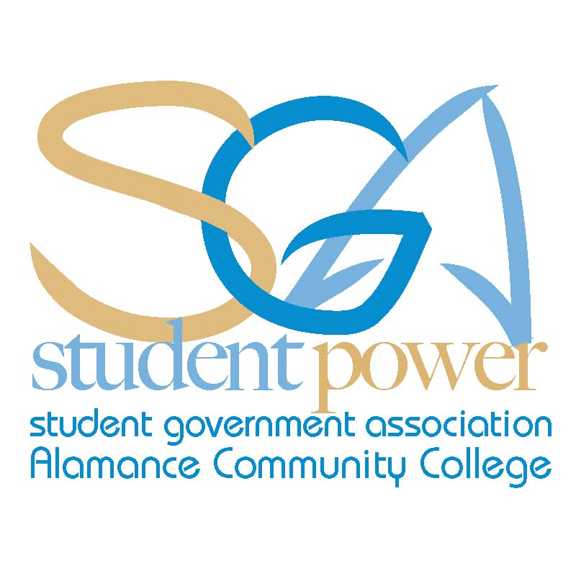
ACC SGA Agenda Monday, September 9, 2013
"Imagination is more important than knowledge. For knowledge is limited, whereas imagination embraces the entire world" — Albert Einstein
Call To Order:
- Attendance:

Chris Seip
Jeff Webster
Jodie Thompson
Cynthia Thompson
Animal Care
Asian Pop Culture
Automotive Club
Basic Law Enforcement
Christian Outreach
Cosmetology
Criminal Justice Club
Creative Writing
Culinary Team
Dental Assisting
Electric Vehicle Club
Flora Club
History Club
International Friend.
Machine Worx
Math Club
Medical Assisting
Music and Dance
Phi Theta Kappa
Rotaract Club
Sigma Delta Mu
Sigma Psi
Spanish Club
Student Nurses Assoc.
Sustainable Environ.
Visual Arts Club

- Approval of Minutes (No minutes to review)
- Guest Speakers
  - Beth Brehler / Courtney Doi
- Office Reports:
  - President
    - Division Meeting Oct 5th
  - Vice President
    - Senator Interviews
  - Secretary
    - SGA Conference Sign Up
  - Treasurer
    - SGA Budget Update
  - Advisor
    - Club Email Accounts
- Club Reports:
- Unfinished Business: (No unfinished business)
Fall 2013 SGA Meeting Schedule
All meetings will take place at 11:30 am in room 230 of the Student Center
Monday, October 10th
Monday, November 4th
Monday, December 2nd
- New Business:
- Announcements:
  - Going Green Presentation –Today at 9/9/13 @1:00 pm
  - Constitution Day-September 17th
  - Study Skills Workshop-Sept. 18/19th 11:15-12:15 Room 230
  - HIV Testing-Wednesday, Sept.18th 11:00 am-1:00 pm
  - Social Media Etiquette-Tuesday, Sept. 24th
- Adjournment:

