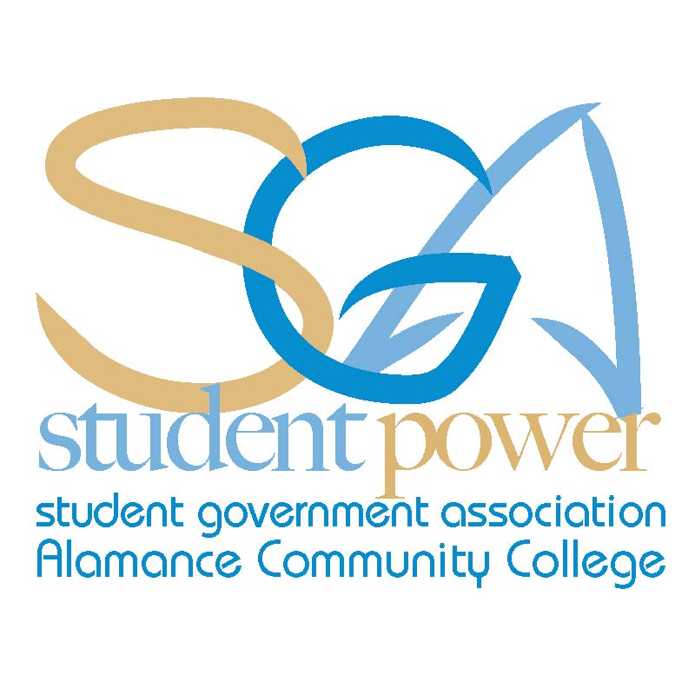
ACC SGA Agenda Monday, August 26, 2013
"A good character is the best tombstone. Those who loved you and were helped by you will remember you when forget-me-nots are withered. Carve your name on hearts, not on marble." — Charles Spurgeon
Call To Order:
- Attendance:

Chris Seip
Jeff Webster
Jodie Thompson
Cynthia Thompson
Animal Care
Asian Pop Culture
Automotive Club
Basic Law Enforcement
Christian Outreach
Cosmetology
Criminal Justice Club
Creative Writing
Culinary Team
Dental Assisting
Electric Vehicle Club
Flora Club
History Club
International Friend.
Machine Worx
Math Club
Medical Assisting
Music and Dance
Phi Theta Kappa
Rotaract Club
Sigma Delta Mu
Sigma Psi
Spanish Club
Student Nurses Assoc.
Sustainable Environ.
Visual Arts Club

- Approval of Minutes (No minutes to review)
- Guest Speakers: (No Guest Speakers)
- Office Reports:
  - President
  - Vice President
  - Secretary
  - Treasurer
  - Advisor
    - National Society of Leadership and Success
      - Exec. Board
    - Campus Committees Assignments
    - Division Meeting
    - SGA Conference
    - SGA Senators
    - NCSU Class time (Every Thursday)
    - Club Email Accounts
    - Duplicating Codes
Fall 2013 SGA Meeting Schedule
All meetings will take place at 11:30 am in room 230 of the Student Center
Monday, September 9th
Monday, October 10th
Monday, November 4th
Monday, December 2nd
    - Activity Planning / Additional Events

- Club Reports:
- Unfinished Business: (No unfinished business)
- New Business:
- Announcements:
  - SGA Calendar of events
  - Constitution Day-Tuesday, September 17th
  - Facebook / Twitter Accounts
- Adjournment:

