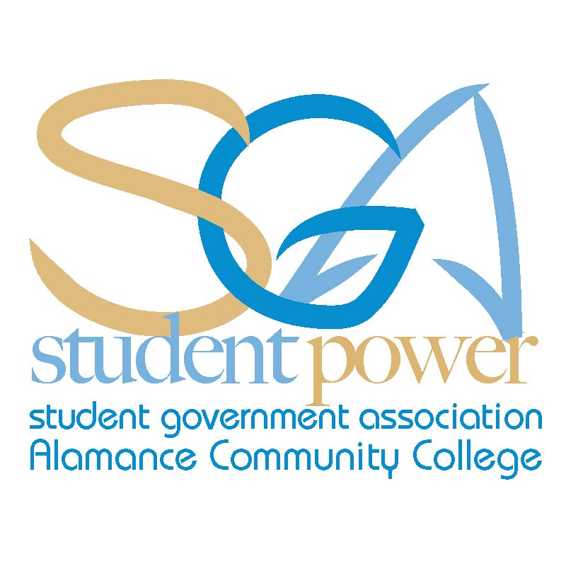
ACC SGA Agenda Monday, November 4, 2013
“Thankfulness is the beginning of gratitude. Gratitude is the completion of thankfulness. Thankfulness may consist merely of words. Gratitude is shown in acts. “
Henri Frédéric Amiel (27 September 1821 – 11 May 1881) was a Swiss philosopher, poet, and critic.
Call To Order:
- Attendance:

Chris Seip
Jeff Webster
Jodie Thompson
Cynthia Thompson
Animal Care
Asian Pop Culture
Automotive Club
Basic Law Enforcement
Christian Outreach
Cosmetology
Criminal Justice Club
Creative Writing
Culinary Team
Dental Assisting
Electric Vehicle Club
Flora Club
History Club
International Friend.
Machine Worx
Math Club
Medical Assisting
Music and Dance
Phi Theta Kappa
Rotaract Club
Sigma Delta Mu
Sigma Psi
Spanish Club
Student Nurses Assoc.
Sustainable Environ.
Visual Arts Club

- Approval of Minutes
- Guest Speakers:
- Office Reports:
  - President
    - Conference Review
  - Vice President
  - Secretary
    - Community Service Project
  - Treasurer
    - Budget Update
  - Advisor

- Club Reports:
- Unfinished Business: (No unfinished business)
- New Business:
- Announcements:
  - Veterans Day Breakfast-Mon., Nov. 11th
  - Career Planning Workshop-Tues., Nov 12 12:30 - 1:30 pm
  - LinkedIn Workshop-Wed., Nov 13th 12:30 – 1:30 pm
  - Volunteer for your career Workshop-Thur. Nov. 14th 12:30 – 1:30 pm

- Adjournment:

Fall 2013 SGA Meeting Schedule
All meetings will take place at 11:30 am in room 230 of the Student Center
Monday, December 2nd

