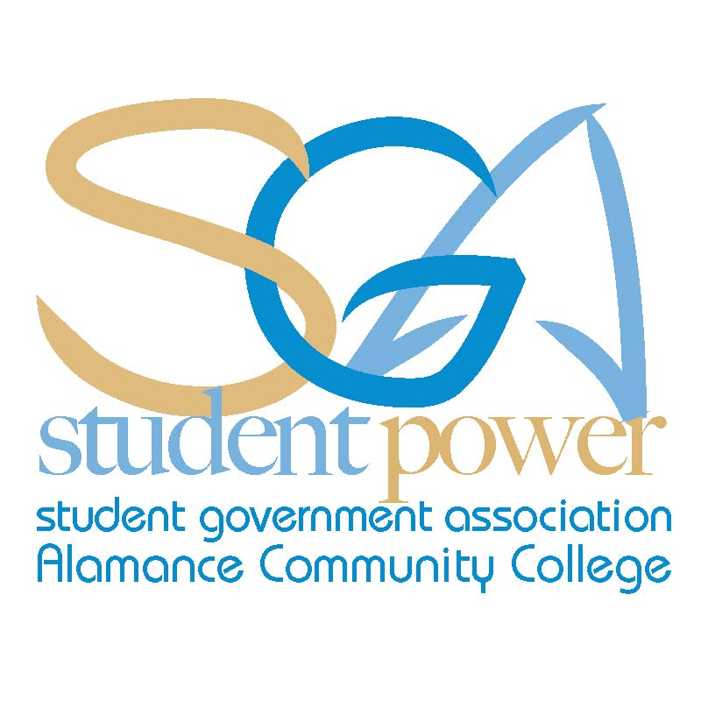 ACC SGA Agenda Monday, October 7th, 2013
"Success is never final. Failure is never fatal. It is courage that counts." —Winston Churchill
Call To Order:
- Attendance:

Chris Seip
Jeff Webster
Jodie Thompson
Cynthia Thompson
Animal Care
Asian Pop Culture
Automotive Club
Basic Law Enforcement
Christian Outreach
Cosmetology
Criminal Justice Club
Creative Writing
Culinary Team
Dental Assisting
Electric Vehicle Club
Flora Club
History Club
International Friend.
Machine Worx
Math Club
Medical Assisting
Music and Dance
Phi Theta Kappa
Rotaract Club
Sigma Delta Mu
Sigma Psi
Spanish Club
Student Nurses Assoc.
Sustainable Environ.
Visual Arts Club

- 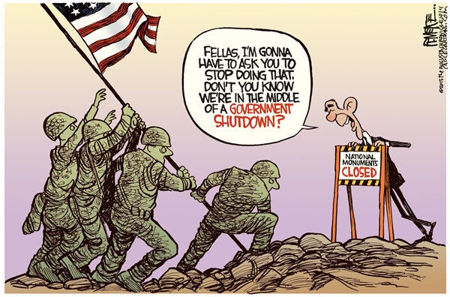Approval of Minutes
- Guest Speakers
  - Dr. Algie Gatewood
- Office Reports:
  - President
  - Vice President
  - Secretary
  - Treasurer
  - Advisor
- Club Reports:
- Unfinished Business: (No unfinished business)
- New Business:
- Announcements:
  - Test Anxiety Workshop Tues. / Wed Oct. 8th – 9th
11:15 am – 12:15 am Room 230
  - Fall Break-Mon. Oct. 14 – Fri.18th
  - Kevin Bracy Redo: Fri, Oct. 11th 1:00 – 2:00 pm
  - Common Live Broadcast Tues. 7-8:00 pm
Redo: Friday, October 25th 1:00 -2:00 pm
  - Student Success Workshop-Oct. 23rd / 24th
11:15-12:15 Room 230
  - HIV Testing-Wednesday, Oct. 23rd 11:00 am-1:00 pm
  - Robert Stevenson Live Tuesday, Oct. 29th 7:00 - 8:00 pm
Redo: Friday, November 8th 1:00 – 2:00 pm
  - Nursing Blood Drive-Thursday, October 31st
8:00 – 5:00 am
- Adjournment:
Fall 2013 SGA Meeting Schedule
All meetings will take place at 11:30 am in room 230 of the Student Center
Monday, November 4th
Monday, December 2nd

