ALAMANCE COMMUNITY COLLEGE
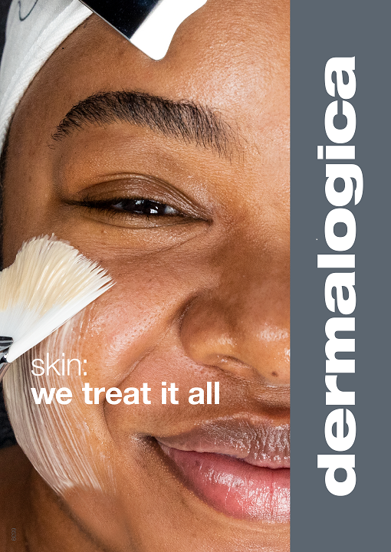
ESTHETICS PROGRAM
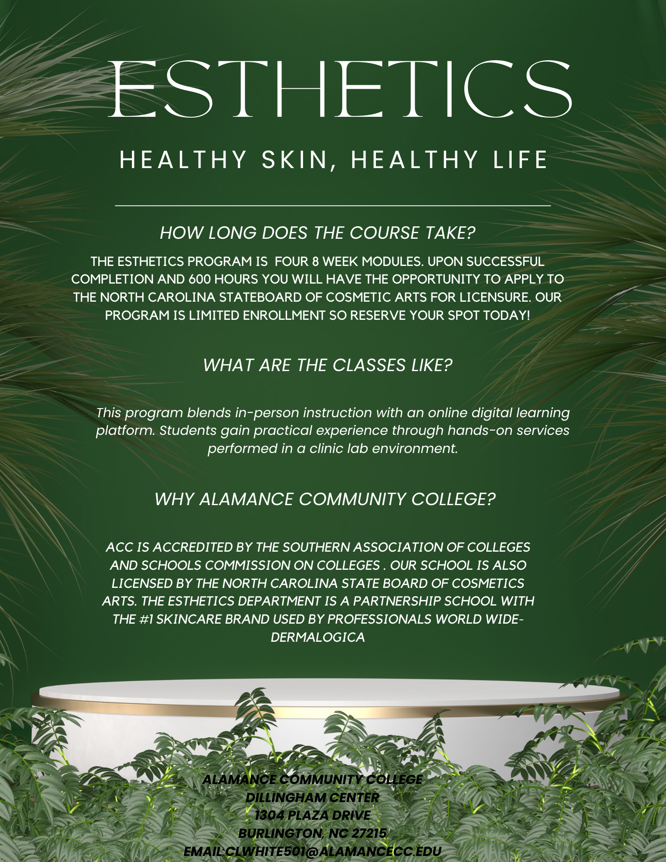
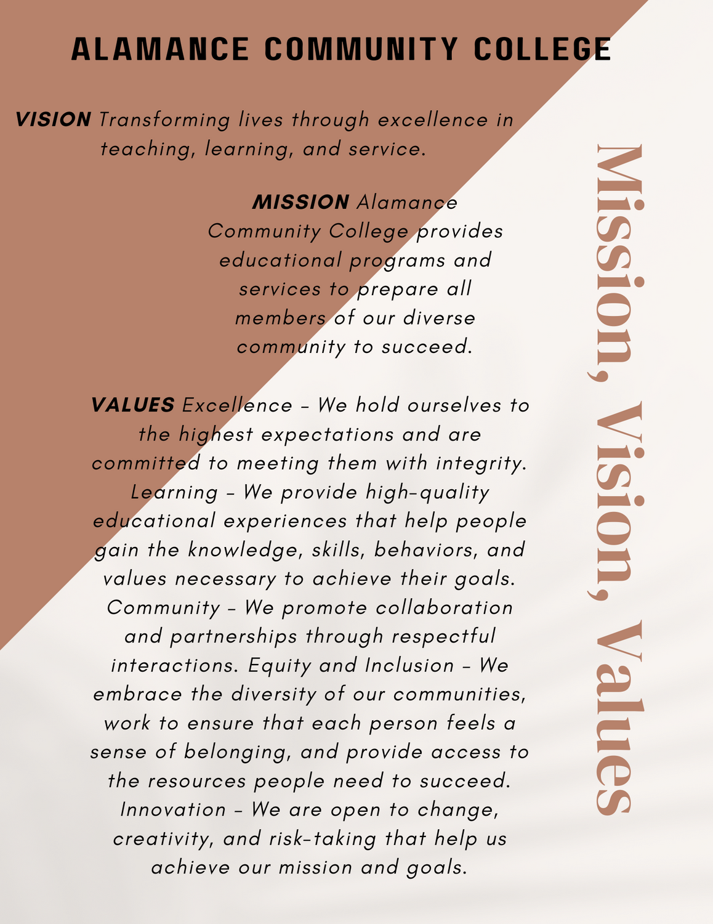
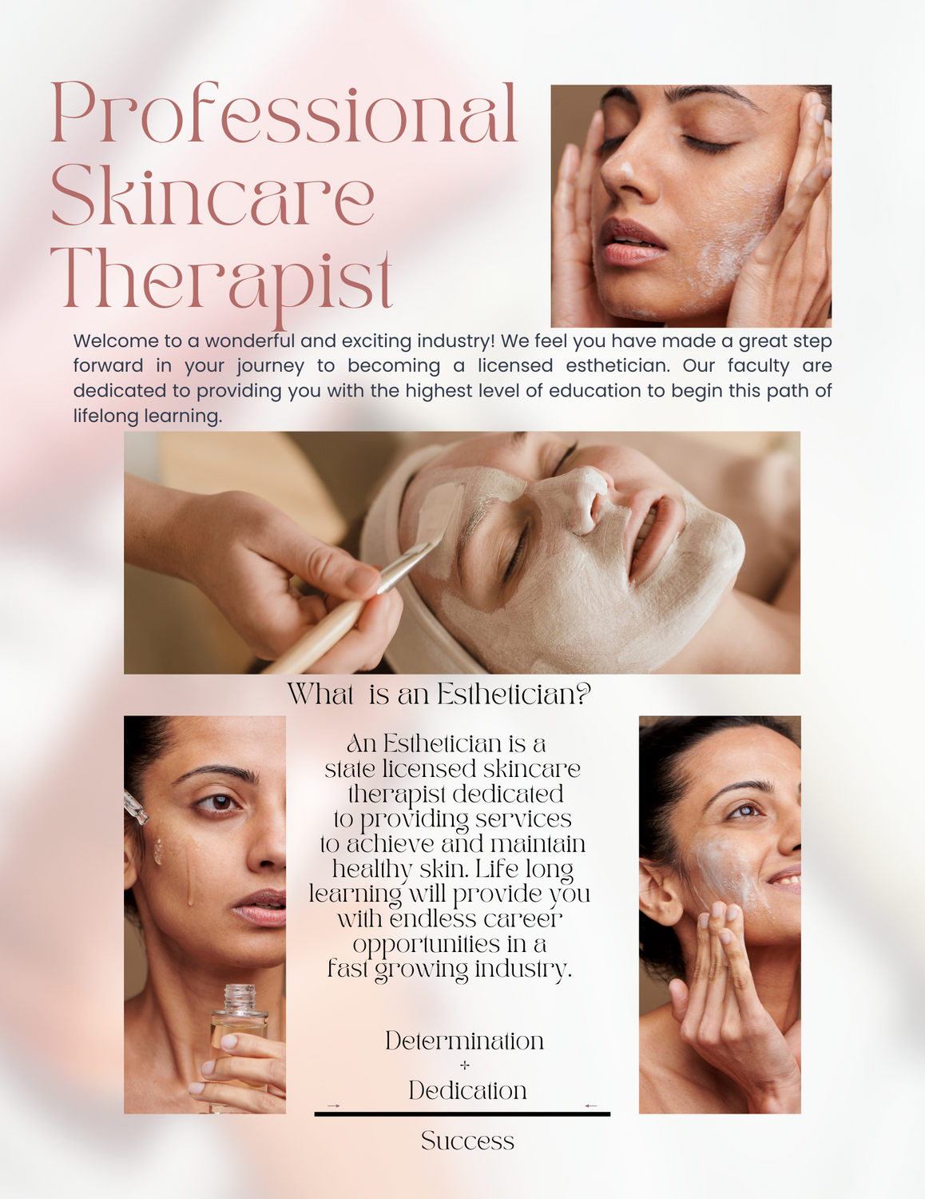
STEPS TO APPLY FOR COLLEGE CREDIT
Do you want to earn an associate degree, diploma, or certificate? Do you plan to transfer from Alamance Community College to another college or university? Let us help you move quickly through these steps.
APPLICATION STEPS
New students and returning students must follow these steps to apply to ACC. Once you have completed step one (residency determination), you can work on multiple steps at the same time.
If you need help with any steps in the application process, email admissions@alamancecc.edu or call 336-506-4270.

 | Determine Your State Residency  Your residency status determines how much tuition you pay.  Check or establish your state residency here.  The residency determination must be done prior to your application submission.
 | Submit Your Application  Complete the online admissions application.  Choose an Academic and Career Pathway.  Students interested in transferring to a four-year college/university should enroll as a degree-seeking student in the University Transfer program of choice.
 | Submit official transcripts to Student Records  Degree seeking students must request and submit an official, final high school transcript or high school equivalency scores.  Students who have earned an Associate Degree or higher from an accredited college or university may waive this requirement if transcripts documenting higher degrees are received.  If you are seeking transfer credit or need prerequisite verification, submit an official transcript for colleges/universities attended.
 | Set Up Your ACC Account and Activate Your Email  You will receive your account information in the ACC welcome packet by email.  Promptly activate your ACCess account so you can receive pertinent information regarding registration, financial aid, orientation, and current events.  Click here for instructions on setting up your ACCess account.
 | 5a  Complete the FAFSA at studentaid.gov.  This process is a two step process. After completing the FAFSA application, you will receive an email notification to your ACC email account. This process may take up to seven business days.  For assistance, contact Financial Aid at 336-506-4340  5b  Apply for ACC Foundation Scholarships once your ACCessaccount has been created.  Apply for ACC Foundation Scholarships once you have set up your ACCess account.

Example welcome letter:
Greetings Everyone!
Welcome to Esthetics at Alamance Community College! Thank you so much for choosing us as your educational pathway to such an amazing industry. This letter is to provide all the information you need for your class. On the first day of class once you have access to your email and Moodle, log into your Moodle (Cos 119 AB and Cos 120AB) and complete the Enrollment Verification Quiz for both classes. I am attaching information for you to get into your Moodle if you have not set up your accounts yet. We will be having orientation on the first day of class to go over expectations. The times for you are listed below accompanied by all your school supplies and information regarding your schedule. IMPORTANT!! PLEASE READ THOROUGHLY There is a link that you will need to upload your documents (social security card and official government id (license or passport) You must fill this enrollment form out and get it uploaded to the NC Board of Cosmetic Arts Examiners prior to your 1st day of class. Once you have completed the document you will receive an email with pending status. Please forward that email to Heather Laws at htlaws057@alamancecc.edu If you do not receive pending status or you do not have your documents, you cannot enter the program until you do. The link is here! https://accesshub.nccosmeticarts.com/
Please call or email me if you have any questions! 336-506-4393 htlaws057@alamancecc.edu
CLASS LOCATION AND SCHEDULE
1304 Plaza drive Burlington NC at the Dillingham Center room 150.
Cos 119ab-Online
Cos 120ab Monday, Tuesday, and Wednesday 9:00am to 3:00 pm
HOW TO PAY FOR YOUR CLASSES
You can pay per semester; you may also set up a payment plan through your self-service. The Esthetics Program at Alamance Community College is not a Title IV eligible program currently. Any courses associated with the Esthetics Program will not qualify for any federal or state grants funds. You may however be eligible for a scholarship. Follow the link below for application. Should you have any questions or concerns, please do not hesitate to contact financial aid regarding any aid for this type of certificate course. (336)-506-4161
Ways to pay- https://www.alamancecc.edu/how-to-pay/paying-for-acc.php
SCHOOL SUPPLIES
Textbooks and Kit: The textbooks, CIMA (online platform), and kit will be available in the department for purchase on the first day of school.
Uniform information:
Student ID and parking pass link:
https://www.alamancecc.edu/public-safety/parking-and-transportation/index.php
Scrubs:
Royal Blue scrub top and pants. You can purchase them from the store of your choice or online. Click the link to see examples.
https://www.scrubsandbeyond.com/royal-blue-scrubs.html?p=2
Closed toed shoes with socks

Alamance Community College Online information
How to set up your student account: This link will provide you the information to set up your ACC accounts; self-service, email, and Moodle.
https://www.alamancecc.edu/campus-it/student-account.php
Download the safe APP
Please complete the steps to download the ACC safe app. This will allow you to have update information regarding college announcements.
https://www.alamancecc.edu/public-safety/acc-safe-app/index.php
Student Resources
Visit the student resource page to see all the great things ACC has to offer you as a student!
https://www.alamancecc.edu/services-and-support/student-resources/untitled.php
Estimated Program Cost
MODULE 1
The first 8-week module COS 119AB and COS 120AB:
$150 esthetics kit
$534 esthetics books including the online platform CIMA
$125 student fee
$400 tuition
Student ID-Complimentary
$100 uniforms (from the source of your choice)
$1,409

MODULE 2
The second 8-week module COS 119BB and COS 120 BB
$125 student fee
$400 tuition
$525

MODULE 3
The third 8-week module COS 125AB and COS 126AB
$125 student fee
$400 tuition
$525

MODULE 4
The fourth 8-week module COS 125BB and COS 126BB
$125 student fee
$400 tuition
$525

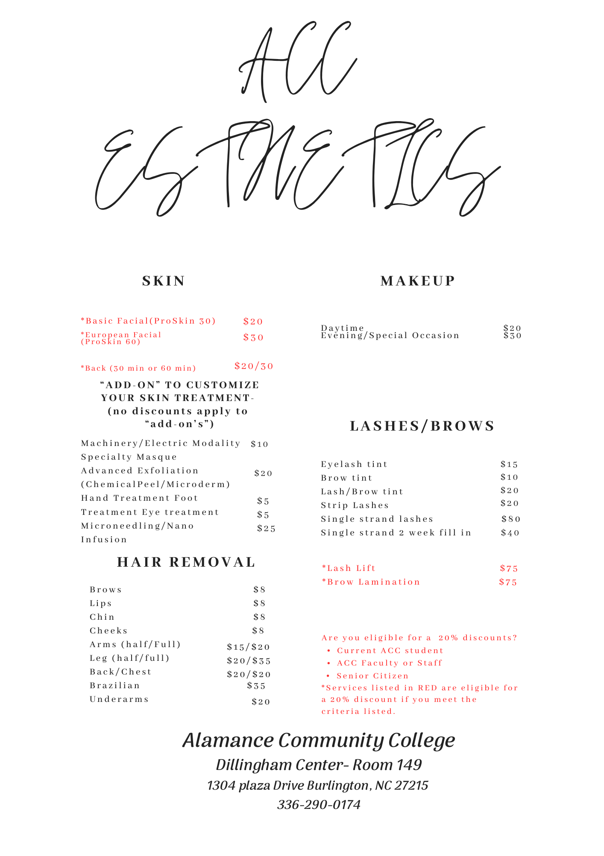

Grading Scale
Alamance Community College uses the 10-point grading scale. A grade of 70% or higher is required to move to the next module.
100-90=A
80-89=B
Concept classes (COS 119 and COS 125) consist of:
25% chapter tests
25% assignments, homework, projects
25% attendance
25% final exam
Salon classes (COS 120 and COS 126) consist of:
25% evaluations
25% assignments, homework, projects, online booking (Fresha), participation, daily/weekly clinic grades, desk/dispensary, uniform, professional image.
25% attendance
25% final exam

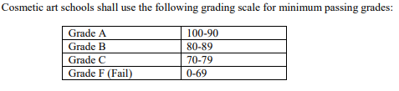

Uniform
The ACC esthetics uniform is royal blue scrub top and pants. The uniform should fit according to your body size, no exposed skin and pants should not touch the floor. No jackets, hoodies, coats, etc. may be worn while on the clock. Royal blue lab coat or under shirt is allowed if needed. Name tag (photo ID from the college) must be worn at all times. Comfortable, washable shoe is required. PLEASE no sandals, boots, bedroom shoes, slippers, etc. Hair should be neatly styled and pulled back if necessary. Your hair should not be able to touch the client or be in a style that requires you to continually touch throughout a service due to infection control requirements. Nails should be clean and neat and not exceed the end of your fingertip. Makeup (if worn) should look professional. Jewelry is not allowed to come in contact with the client and cannot be worn on the hands or wrists.
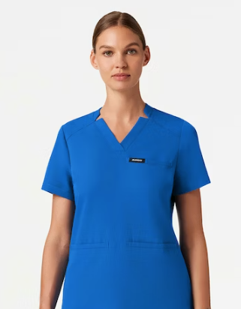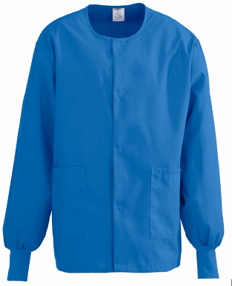
Class Expectations
- Be on time!
- Participate in class
- Perform services
- Be in uniform and look professional
- Behave professionally
- Practice skills outside of school on your mannequin
- Complete homework
- Recruit and Re-book clients

Class Schedule

Module 1 (8 Weeks)
Course | Format / Schedule | Required Hours | Maximum Missed Time
COS 119 AB | Online | 16 contact hours | 2 hours (120 minutes)
COS 120 AB | M, T, W  9:00 a.m.–3:00 p.m. | 144 contact hours | 8 hours (480 minutes)

Module 2 (8 Weeks)
Course | Format / Schedule | Required Hours | Maximum Missed Time
COS 119 BB | Online | 16 contact hours | 2 hours (120 minutes)
COS 120 BB | M, T, W  9:00 a.m.–3:00 p.m. | 144 contact hours | 8 hours (480 minutes)

Module 3 (8 Weeks)
Course | Format / Schedule | Required Hours | Maximum Missed Time
COS 125 AB | Online | 16 contact hours | 2 hours (120 minutes)
COS 126 AB | T, W, Th  9:00 a.m.–3:00 p.m. | 144 contact hours | 8 hours (480 minutes)

Module 4 (8 Weeks) * 30-Hour Internship Option
Course | Format / Schedule | Required Hours | Maximum Missed Time
COS 125 BB | Online | 16 contact hours | 2 hours (120 minutes)
COS 126 BB | T, W, Th  9:00 a.m.–3:00 p.m. | 144 contact hours | 8 hours (480 minutes)
Students must successfully complete each module with a minimum grade of 80% and not exceed the maximum missed time allowed for that module to advance to the next module. Failure to meet either requirement will result in the student repeating the module as space allows.

COS 119AB (1st 8 weeks)
COS 119AB (16 hours online) Online component- CIMA.
Week #1- Orientation- Welcome!! Handout and review syllabus and course outline, cosmetology handbook, class schedule, clocking in and out procedure, esthetics curriculum, esthetics kit, copy of SB sanitation rules, Moodle-take online verification quiz, access school email, access online platform (CIMA)
Week 2
Read Chapter 5 Infection Control (foundations book) and complete CIMA assignments
Week 3
Read Chapter 5 Skin Analysis (standard book) and complete CIMA assignments
Week 4
Read Chapter 7 The Treatment Room (standard book) and complete CIMA assignments
Week 5
Read chapter 9 Facial Massage (standard book) and complete CIMA assignments
Week 6
Read Chapter 8 Facial Treatments (standard book) and complete CIMA assignments
Week 7
Read Chapter 10 Facial Devices and Technology (standard book) and complete CIMA assignments
Week 8
Final Exams- Complete timed 100 question multiple choice test (90 minutes) over subject matter covered these 8 weeks; chapter 5 infection control (foundations book), chapter 5 skin analysis, chapter 7 the treatment room, chapter 8 facial treatments, chapter 9 facial massage, chapter 10 facial devices and technology (standard textbook).

Cos 120AB
(1st 8 weeks)
Cos 120-AB (144 face to face)
- Orientation- Welcome!! Review syllabus and course outline, cosmetology/esthetics handbook, class schedule, clocking in and out procedure, esthetics curriculum, esthetics kit, copy of SB sanitation rules, Moodle-take online verification quiz, access school email
Make Dermalogica account at pro.dermalogica.com
Undergrad Student Profile Creation:
- Go to: https://pro.dermalogica.com
- Click Create Log In
- Fill in name, email, choosing Undergrad as Role
- When asked for Phone Number or Access Code they’ll choose Access Code
- Undergrad Assess Code: partnershipschool
- Add mailing address and phone number
- After receiving the Success message they’ll login using their email and the one time temporary password: D3rmalogica!
- Then you’ll reset your password and be able to login and can click Book future Workshops to register for the assigned workshops (for help with logging in call Dermalogica’s Education Department 1-888-292-5277)
Complete both Dermalogica workshops- get started with Dermalogica, franchise focus, - Due:___________________
Send badges of completion to ________________________ with your name and class title in the subject line.
Review the Dermalogica expert checklist posted on Moodle and “The Book”.
Product Knowledge-(see detailed list)
Weeks 2-7
- Handwashing
- Disinfecting an Implement
- Beginning and End of the day
- Blood Exposure-self
- Blood exposure-client
- Product knowledge (see detailed list)
- Skin Analysis/Client Consultations
- Preparing a treatment room
- Touch therapy
- Facials/ProSkin 30/introduction to ProSkin60
- Machinery- galvanic, high-frequency (direct and indirect), ultrasonic blade, brush, spray-vac, steamer, Dr. Lucas, towel cabinet
Week 8 Final exam (ProSkin 30)
All instruction in a cosmetic art school shall be in this order:
(1) Guided theory
(2) Demonstration
(3) Guided practice
(4) Independent theory
(5) Practice
(6) Evaluation and passage of evaluation
(7) Performance.

Product Knowledge

Cleansers
Precleanse/Micellar prebiotic precleanse
Ultracalming
Special Cleansing Gel
Intensive Moisture
Skin Resurfacing
Daily Glycolic
Clearing Skin Wash
Oil to foam
Magnetic + afterglow cleanser
Toners
Ultracalming Mist
Multi-active
Antioxidant Hydramist
Hyaluronic Ceramide mist

Resurfacing
Daily Microfoliant
Daily Milkfoliant
Daily Superfoliant

Extractions
Multi-active scaling gel
Post extraction solution

Touch Therapy
Massage gel cream

Deep Treatment
Professional Serums:
Hyaluronic Ionactive serum
Biolumin-C Prol serum
Niacinamide Ionactive serum
Powerbright Ionactive serum
Retinol Ionactive serum
Retail Serums:
Ultracalming serum concentrate
Circular hydration

Masques:
Colloidal masque base
Conductive masque base
Clinical oatmeal masque
Multivitamin power recovery masque
Sebum clearing masque
Light energy masque

Dermal Layering
Active moist
Skin smoothing
Intensive moisture
Super rich repair
Biolumin-C gel
Calm water gel
Stabilizing repair cream
Dynamin skin recovery spf 50
Invisible physical defense spf 30
Skin perfecting primer spf 30

Misc.
Calming botanical mixer

OL Classes
Prevention
Get started with Dermalogica
Franchise Focus

Facemapping
Skin fitness plans

COS 119 (2nd 8 weeks)
Cos 119-BB (16 hours online) Online component- CIMA.
1. Chapter 3 Skin Physiology and Histology

2. Chapter 4 Diseases and Disorders of the Skin

3. Chapter 6 Skincare Products: Chemistry, Ingredients, and Selection

4. Chapter 11 Hair Removal

5. Chapter 2 Anatomy and Physiology

6. Chapter 12 Makeup Essentials

7. Chapter 13 Advanced Topics and Treatments

8. Exams
Final Exams- Complete timed 100 question multiple choice test (90 minutes) over subject matter covered these 8 weeks

COS 120BB (2nd 8 weeks)
Cos 120-BB 144 face to face)
Orientation- Welcome!! Review syllabus and course outline, cosmetology/esthetics handbook, class schedule, clocking in and out procedure, esthetics curriculum, esthetics kit, copy of SB sanitation rules, Moodle-take online verification quiz, access school email

Brow Mapping
Waxing (face)
Artificial Lashes (band)
Lash and Brow Tinting, Henna, Stain
Makeup
Back Facials
Hydrojelly Masque
Chemical Peeling
Final Exam- ProSkin 60

All instruction in a cosmetic art school shall be in this order:
(1) Guided theory
(2) Demonstration
(3) Guided practice
(4) Independent theory
(5) Practice
(6) Evaluation and passage of evaluation
(7) Performance

Product Knowledge
Dermalogica
Resurfacing
Multiviamin Thermafoliant
Multivitamin Power Exfoliant
Exfoliant Accelerator 35
One step prep
Powerclear Peel
Ultrabright Peel
Advanced renewal Peel
AGE reversal Peel
Salicylic 15% gel Peel
Neutrailizing solution
Touch Therapy
Soothing additive
Masques
Neck Refining Masque
Dermal Layering
Retail Serums
Biolumin C
Eye creams
Multivitamin power firm
Biolumin C
Awaken Peptide Eye Gel
Age Reversal Eye Complex
Total Eye Care
*Lash and Brow Tint, Henna, Stain
*Hair Removal soft and hard wax

Esthemax
Hydro Jelly Masques
AHA BHA
Antioxidant Gojo
Australian Sheep Placenta
Belgium Cacao
Beta-Carotene Floral
Blue Glacier Cryo
Brightening Complex
CBD 1000MG Dope
CHI Energy Infused
Cica Complexion Care
Discoloration Alpha Arbutin
Discoloration Corrector
Eygptian Rose
Enzyme Powder 113
Glutathione
Green Tea Tree
Hyaluronic Acid
Illuminating Orange
Intensive Aftercare
LED Lisght See-Through
NAD+Longevity
Phyto-Nutrients Blast
Pure Himalayan White Tea
Purifying Actived Charcoal
Radiance Biotin
Renewal Boost
Resilience Cavier
Retinol Alternative
Rosehip Hop
Salmon DNA PDRN
Silk Cocoon Peptide
Skin Warrior Ageless
Spot Diminishing ALA
Supper Greens Strength
Vampire PLLA infusion
Silk Cocoon Peptide
Wildcrafted Sea Moss
Youthful Elixir
COS 125AB (3rd 8 weeks)
Cos 125-AB (16 hours) Online component- CIMA.
1. Chapters 1-4; Life Skills, Professional Image, Communicating for Success
2. Chapter 6 Chemistry and Chemical Safety
3. Chapter 7 Electricity and Electrical Safety
4. Chapter 8 Career Planning
5. Chapter 9 On the Job
6. Chapter 10 The Beauty Business
7. Chapter 1 History and Career Opportunities
8. Exams
Final Exams- Complete timed 100 question multiple choice test (90 minutes) over subject matter covered this 8 weeks

COS 126AB (3rd 8 weeks)
Cos 126-AB 144 face to face)
Orientation- Welcome!! Review syllabus and course outline, cosmetology/esthetics handbook, class schedule, clocking in and out procedure, esthetics curriculum, esthetics kit, copy of SB sanitation rules, Moodle-take online verification quiz, access school email
- Brow Lamination/ Lash Lift
- Lash Extensions (single strand)
- Exfoliation (Physical)
- Dermal Planing
- Microneedling
- Spray Tanning
- Body Treatments/Body Waxing
- Exams (Procedure notebook)
All instruction in a cosmetic art school shall be in this order:
(1) Guided theory
(2) Demonstration
(3) Guided practice
(4) Independent theory
(5) Practice
(6) Evaluation and passage of evaluation
(7) Performance

Product Knowledge

COS 125BB (4th 8 weeks)
Cos 125-BB (16 hours) Online component- CIMA.
- Review CIB NC Stateboard of Cosmetics Arts Theory Exam
- Review Scientific Concepts
- Review Skincare and Services
- Stateboard worksheet
- Stateboard worksheet
- Stateboard worksheet
- Stateboard worksheet
- Exams- Complete timed 100 question multiple choice test (90 minutes)
COS 126BB (4th 8 weeks)
Cos 126-BB 144 face to face) Internship option available! See your instructor for details!!
Orientation- Welcome!! Review syllabus and course outline, cosmetology/esthetics handbook, class schedule, clocking in and out procedure, esthetics curriculum, esthetics kit, copy of SB sanitation rules, Moodle-take online verification quiz, access school email
NC StateBoard of Cosmetic Arts licensure
State Board Exam Prep
CIB exam review
kit prep and label
demo of exam
walk-thru exam
practice exam
timed practice
graded timed practice

Environ
Sugaring
Advanced Lash Techniques
Lymphatic Drainage-Powerderm Kinetic Dermabrasion
Airbrush Makeup
All instruction in a cosmetic art school shall be in this order:
(1) Guided theory
(2) Demonstration
(3) Guided practice
(4) Independent theory
(5) Practice
(6) Evaluation and passage of evaluation
(7) Performance

Product Knowledge

Fresha Grading Scale
- Fresha is graded daily
- Complete and accurate details are required to receive a 100%. There are no partial grades given (it can only be a 0 or 100) so please take your time when filling out your daily records on Fresha.
- If you are absent, you will receive a zero for your daily grade
- If you are tardy or leave early, you will receive a zero in Fresha and your attendance grade will be adjusted accordingly
- Beginning and end of the day infection control must be recorded
- Breaks or lunches must be recorded
- Desk/Dispensary duties must be recorded
- Every minute/hour of the day must be recorded with detail and legible. If you are working on a client please make sure that it represents all of the services the client is receiving. Sometimes guests will add on services during their scheduled treatment!
- If you are not doing a client, there will be a list of approved tasks that you can do to receive a 100 see your instructor for details. Our goal is to work on clients all day on our scheduled labs.
- Record your bed/station number at the top of your column in Fresha each day you use the lab.

Desk Duties checklist.
- Turn on lamps around the lab, hot towel cabinets and wax pots.
- Get all client files ready for your fellow students, make sure all paperwork is prepared for returning and new clients.
- Create new client file folders, starting by the last name.
- Load client’s files onto clipboards with pen for the working aesthetician students.
- Assist with spa music on laptop or mini speaker.
- Enter in Fresha app the station number the esthetician students are using.
- Greet incoming clients and take them to the correct esthetician station.
- Make sure all clients Names and information is entered in Fresha app, do not let appointments set up as only walk-in.
- Get the iPad ready to check out clients who are paying with card and the receipt book with cash change for clients who are paying with cash.
- Charge iPad as needed.
- Assist fellow students with clients check out process and pre-book appointments.
- Enter client’s information in face mapping pro.
- Add email address and client information on Fresha app, for them to receive appointment reminders.
- Call and confirm next day appointments.
- Make sure all clients files are alphabetically organized.
- Call clients that haven’t returned and update them with our hours and services.
- Return any calls, and check voice mail twice daily.
- Assist the dispensary as needed throughout the day.
- Check inventory of products and make a list of products that need to be ordered.
- Check inventory of single use items and make a list of items that need to be ordered.

End of the day
- Organized and wiped down the desk.
- Make sure all client’s authorization forms are completed and signed by the esthetician students and clients.
- File all client’s folders in the file cabinet.
- Count cash at the end of the day and make sure is a receipt for each payment made.
- Make sure the receipt book, cash envelope, and iPad are returned to the locker.
- Check the lab for any unplugged equipment.
- Turn off lamps around the lab and spa music.

Dispensary duties checklist
- Mix disinfectant solution per manufacturer instructions,
- Prepare the hot facial cloths needed according to the number of facials.
- Check frequently throughout the day to ensure that it’s adequate supply of hot facials cloths.
- Laundry, wash, dry, fold and put away all linens throughout the day.
- Check changing room for robes in the dirty linens hamper.
- Organize, clean and disinfect equipment when returned to the dispensary disinfected area.
- Clean and disinfect the sinks throughout the day.
- Keep the product cart clean and disinfected throughout the day.
- Restock single use items supply cart throughout the day.
- Ensure that all trolleys are stocked with gloves and disinfectant wipes.
- Cut wax strips, as needed.
- Stock gloves in the dispensary area.
- Assist students with cleaning and disinfecting beds and trolleys If needed.
- Have empty stations clean/disinfected and ready during busy times.
- Assist desk person as needed.

End of the day
- Empty hot towel cabinet and clean/disinfect.
- Empty dispensary garbage can, make sure liner is in place.
- Ensure all equipment are turned off and that there are no cords on the floor and plugged in the wall, including wax pots and hot towel cabinets.
- Empty disinfectant container.
- Make sure there are no implements left behind on the dispensary table.
- Wipe down dispensary table.
- Empty all steamer canisters, clean and disinfect.

Station Checklist
- Clean and disinfect everything at the station (Bed, trolley, lamp, chair, bolster, mirror, trash can, client’s basket, remotes, cords) at the beginning of the day and between clients.
- Fill in the dispenser bottle with distilled water.
- Make sure your station is stock with gloves, hand sanitizer, disinfecting wipes and has both “disinfected container” and “to be disinfected container”
- Add the station number you are using for the day in Fresha app.
- Check your station for any other equipment and items needed for the services you are scheduled for the day (Ultrasonic blade, ultrasonic brush, magnifying lamp, derma plane blade, timer).
- Charge ultrasonic blade.
- Don’t forget to sign the client treatment authorization form and add the client service record and notes to the client’s file.
- During slow times:
- Check Client’s folders to make sure service records and notes are in the file.
- Contact previous clients and update them with your services and availability.
- Assist dispensary and desk.

End of the day
- Clean and disinfect everything at the station, including the ultrasonic blade and any other equipment at the station.
- Empty “to be disinfected” container for any implements that needs to be clean and disinfected.
- Make sure everything is unplugged, and no cords are on the floor.
- Sweep around the station you used.
- Clean any wax or product drips from the floor.
- Make sure there are no implements and brushes left at the dispensary area or in the disinfectant solution.
- Take the trash out.

discover the dermalogica difference
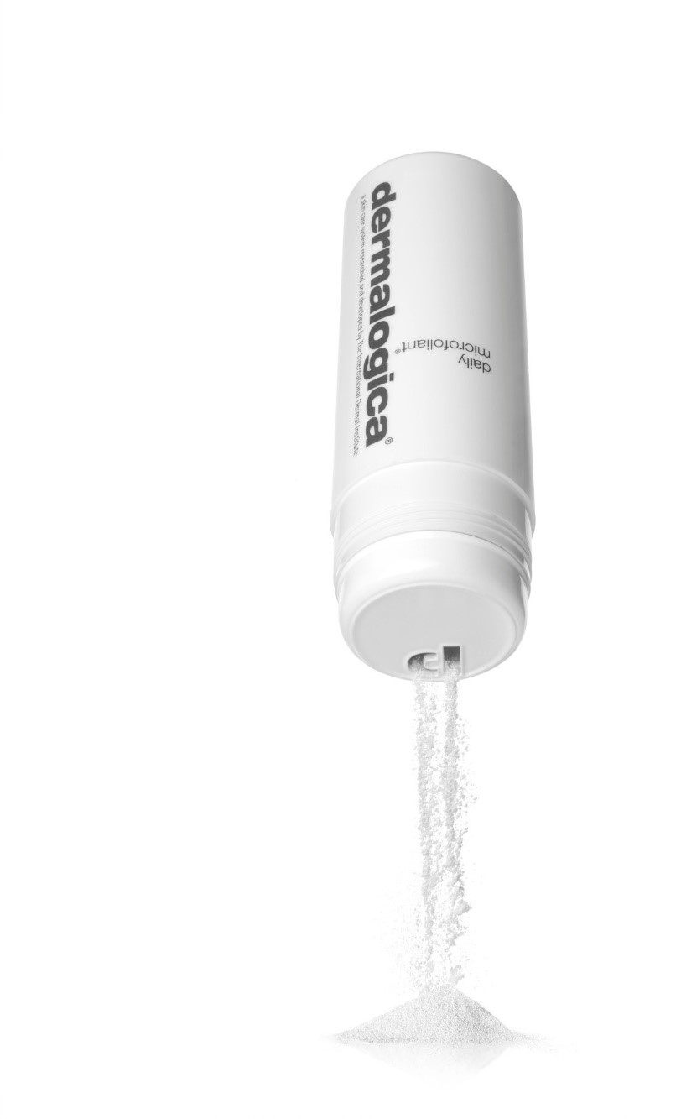
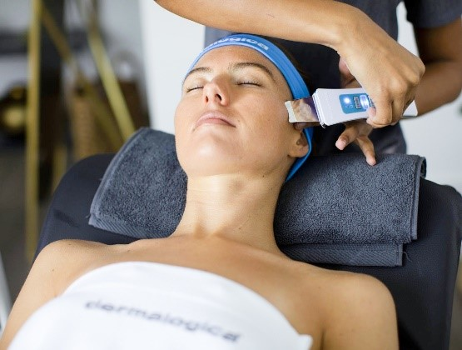
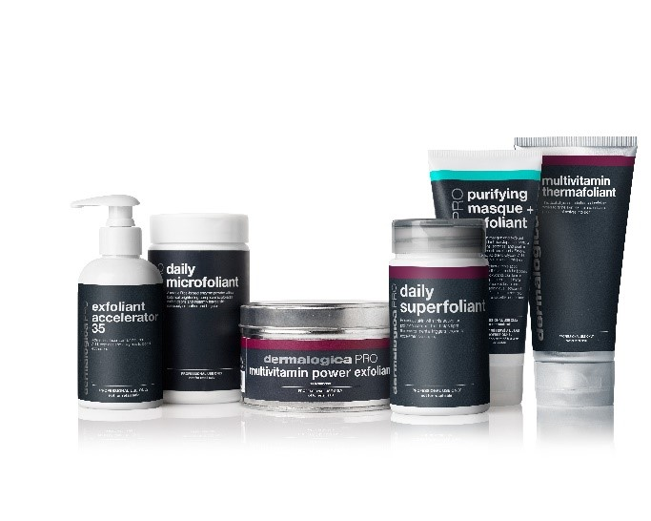
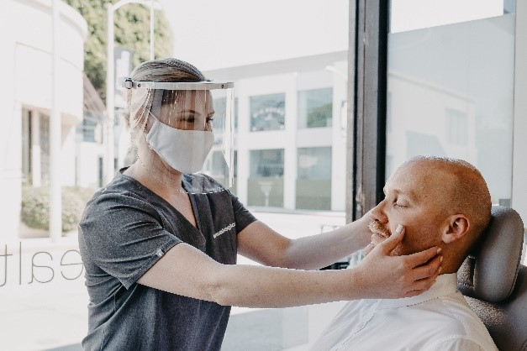
Looking

to

succeed

in

the

business

of

skin?

Choose

a

Dermalogica

Partnership

School!
learn more
get more
stand out in a
crowded market
be more profitable
transition from
student to
professional
Get advanced training with Dermalogica’s
product

segments
,

treatment

protocols

and

Pro
Power

Peel

Collection

which

gives

you

access
to

work

in

over

90

countries

worldwide.
Enhance

your

experience

through

hands-on

practical
application, using Dermalogica professional-grade
products.
Your

elevated

Student

Kit

options

which

includes
the

Pro

Power

Peel

Collection,

ensures

product
and treatment knowledge salons

demand.
Face Mapping skin analysis, Skin Bar, and
ProSkin

30

and

ProSkin

60

treatments

build

your
client

connection

and

potential

revenue

from

retail
sales.
Access

advanced

level

postgraduate

training

through
exclusive

Future

Industry

Professional

Days.

And,

the opportunity

to

apply

for

the

Elevate

Your

Education Scholarship

and

take

classes

with

Dermalogica.
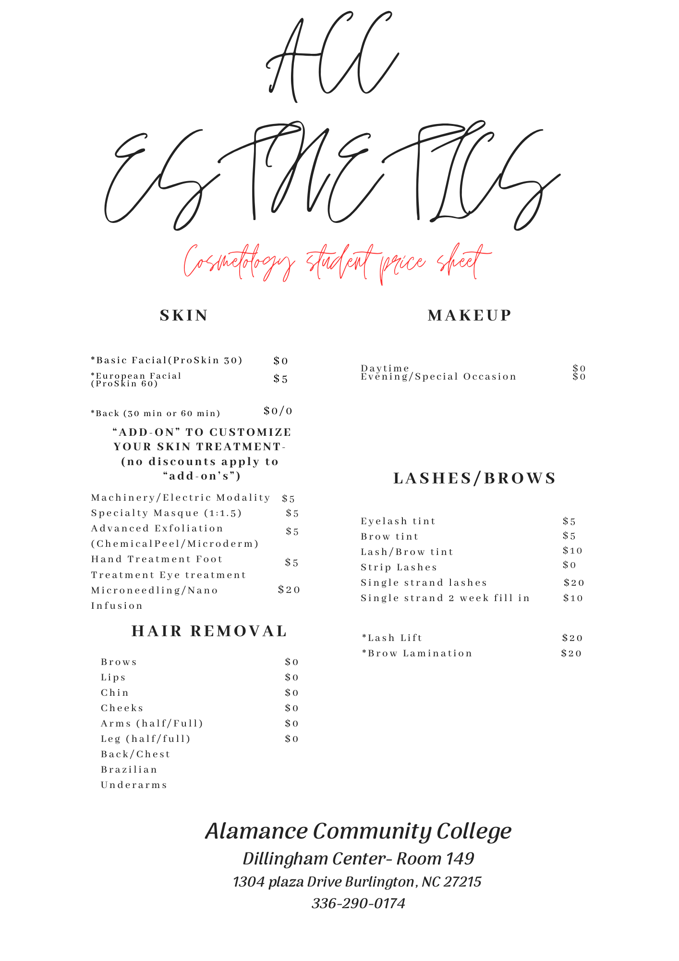

North Carolina Board of Cosmetic Arts
Esthetics Scope of Practice
On August 24, 2020, the North Carolina Board of Cosmetic Art Examiners (the “Board”) issued a declaratory ruling holding that the practice of dermaplaning was not within the scope of practice for cosmetologists or estheticians as set forth in Chapter 88B of the North Carolina General Statutes.
After further consideration, on July 25, 2022, the Board decided to prospectively change its prior declaratory ruling of August 24, 2020 pursuant to N. C. Gen. Stat. §150B-4(a). Accordingly, effective as of July 25, 2022, the Board has determined that because the intention of the services of both dermaplaning and microneedling are the stimulation of the skin, these modalities of services fall within the scope of practice for both estheticians and cosmetologists.
Additionally, effective as of July 25, 2022, the Board has determined, as discussed further in this guidance document, to allow FDA-approved devices to be used for dermaplaning and micro-needling as long as the intent of the service falls within the licensee’s scope of practice. As with all cosmetic art services, licensees must ensure they are fully trained prior to performing these services in order to protect the safety of the consumer.
GUIDANCE
N. C. Gen. Stat. §88B-2(11a) defines “esthetics” as follows: Esthetics. - Refers to any of the following practices: giving facials; applying makeup; performing skin care; removing superfluous hair from the body of a person by use of creams, tweezers, or waxing; applying eyelashes to a person, including the application of eyelash extensions, brow or lash color; beautifying the face, neck, arms, or upper part of the human body by use of cosmetic preparations, antiseptics, tonics, lotions, or creams; surface manipulation in relation to skin care; or cleaning or stimulating the face, neck, ears, arms, hands, bust, torso, legs, or feet of a person by means of hands, devices, apparatus, or appliances along with the use of cosmetic preparations, antiseptics, tonics, lotions, or creams.
The practice of “esthetics” commonly includes but is not limited to: (1) Superficial exfoliation treatments on the epidermis (outer layer of skin) using products or devices used in accordance with manufacturer’s written instructions. (2) Superfluous hair removal on the human body by use of depilatories, tweezers, waxing. (3) Use of esthetic devices, that are intended to be used for cosmetic skin care purposes and improving the appearance of the skin. (4) Make up application on the face and beautifying lashes and brows with the use of products used in accordance with manufacturer’s written instructions. (5) Body treatments, that are intended to be performed for beautifying the skin with the use of cosmetic preparations or devices.
Examples of services that fall within the scope of practice for an esthetician as outlined in N. C. Gen. Stat. §88B-2(11a) and (1) through (5) above are as follows: (1) Exfoliation treatments using products used in accordance with manufacturer’s written instructions. Defined as: (a) Manual scrubs including mechanical brush use. (b) Superficial and light chemical exfoliation including but not limited to; alpha hydroxy acids, beta hydroxy acids, modified Jessner solutions, trichloroacetic acid less than 20%. (c) Vitamin based acids. (d) Any combination of cosmetic preparations intended for light and superficial exfoliation results and used in accordance with manufacturer instructions. (e) Enzymes and/or herbal exfoliators. (2) Use of esthetic devices or any combination of devices that are intended to be used for improving the appearance of the skin.
Esthetic devices allowed must be FDA approved, if FDA approval is required for the classification of the device, be operated within manufacturer written guidelines and FDA registered if required under 201(h) of the Federal Food Drug & Cosmetic (FD&C) Act. Including but not limited to: (a) Low Level radio frequency device (b) Galvanic current (c) High frequency (d) Mechanical brushes (e) Vacuum spray device (f) Steamers (g) Microcurrent devices (h) Microdermabrasion devices (i) Dermaplaning (j) Microneedling device not deeper than 1 mm (k) Magnifying lamp, woods lamp (3) Make up application on the face and beautifying lashes and brows with the use of products used in accordance with manufacturer’s written instructions. Including but not limited to: (a) Artificial lashes (b) Lash and brow tint (c) Lash lift and brow lamination (4) Body treatments which use water, appliances, devices, cosmetic preparations intended to improve the appearance of the skin. Including not limited to: (a) Body scrubs, manually applied with hands or brushes (b) Body wraps using muds, aromatherapy, creams or other specifically designated cosmetic product (c) Dry brushing (5) Extraction techniques including but not limited to: (a) Use of a metal extractor tool (b) Use of a disposable lancet “Esthetics” shall not include any practice, activity, or treatment that constitutes the practice of medicine. Licensed cosmetologists and estheticians are prohibited from using a product, device, machine or technique or any combination of the same, which penetrates the client's skin beyond the epidermis.
Licensed cosmetologists and estheticians are prohibited from diagnosing injury, illness or disease. Use of devices that fall within FDA classifications 3, 3A, 3B, 4 or any Radiation Emitting Devices designation are NOT within the scope of practice. Licensed cosmetologists and/or estheticians cannot state or refer to their licensure or practice as “Medical” or “Master”. Such claims are untruthful and a violation of Board regulations that provide that individuals may not “make any statement to a member of the public either verbally or in writing, stating or implying the licensee or student has completed training, licensure or certification that the licensee/student does not hold or has not completed or not recognized by the Board or NC General Statutes” and further provide that “[a] violation of this prohibition is considered practicing or attempting to practice by fraudulent misrepresentation” under N. C. Gen. Stat. §88B-24. Licensed cosmetologists and estheticians must ensure that they maintain equipment, follow disinfection requirements and perform services in compliance with the Board’s Infection Control administrative rules in 21 NCAC 14H.

Subchapter H Infection Control-
21 NCAC 14H .200, .0300, .0400 and .0500
SECTION .0200 - SHOP LICENSING AND PHYSICAL DIMENSIONS
21 NCAC 14H .0201 APPLICATION FOR SHOP LICENSE
(a) Rules in this Subchapter apply to all cosmetic art shops making initial application to operate a cosmetic art shop. (b) Shops licensed prior to March 1, 2012 may choose to comply with Rules .0202, .0203(c), .0204 and .0301 of this Subchapter. (c) Shops licensed prior to March 1, 2012 must comply with Rules .0201, .0203(a)-(b), .0302-.0304 and Sections .0400 and .0500 of this Subchapter. (d) Shops licensed prior to March 1, 2012 that make any structural changes that change the physical layout or square footage must comply with all rules in this Subchapter. (e) Persons desiring to open a cosmetic art shop, to change ownership of a cosmetic art shop, relocate or reopen a shop shall make application to the North Carolina State Board of Cosmetic Art Examiner on the Board's application form. History Note: Authority G.S. 88B-2; 88B-4; 88B-14; 88B-22; Eff. April 1, 2012; Pursuant to G.S. 150B-21.3A, rule is necessary without substantive public interest Eff. January 13, 2015; Amended Eff. April 1, 2023.
21 NCAC 14H .0202 RESERVED FOR FUTURE CODIFICATION
21 NCAC 14H .0203 NEWLY ESTABLISHED SHOPS
- All cosmetic art shops shall be separate and apart from any building or room used for any other business or purpose, separated by a solid wall of at least seven feet in height and must have a separate outside entrance. (b) A newly established cosmetic art shop, shall be separate and apart from any building or room used for living, dining or sleeping and shall be separate and apart from any other room used for any other purpose by a solid wall of ceiling height, making separate and apart rooms used for a cosmetic art shop. All entrances to the cosmetic art shop shall be through solid, full length doors installed in solid walls of ceiling height. (c) A residential cosmetic art shop shall furnish bathroom facilities separate and apart from the residence. (d) An entrance to a cosmetic art shop from a passageway, walkway, or mall area used only for access to the shop, or to the shop and other businesses, may be open. History Note: Authority G.S. 88B-2; 88B-4; 88B-14; Eff. April 1, 2012; Pursuant to G.S. 150B-21.3A, rule is necessary without substantive public interest Eff. January 13, 2015; Amended Eff. April 1, 2023.

21 NCAC 14H .0204 DIMENSIONS WITHIN COSMETIC ART SHOPS

Within the clinic area each shop shall maintain no less than the following working distances: (1) 48 inches of space from the center to the center of each styling chair, esthetics table or manicuring table; (2) 24 inches from the center of the chair forward; (3) 48 inches from the backrest behind the chair to any other styling chair, esthetics table or manicuring table; and (4) at least 30 inches of space from the back of each styling chair, esthetics table or manicuring table to the wall of the shop. History Note: Authority G.S. 88B-2; 88B-4; 88B-14; Eff. April 1, 2012; Pursuant to G.S. 150B-21.3A, rule is necessary without substantive public interest Eff. January 13, 2015.

SECTION .0300 - COSMETIC ART SHOP AND EQUIPMENT
21 NCAC 14H .0301 WATER
Cosmetic art shops shall have a sink with hot and cold running water in the shop, separate from restrooms. History Note: Authority G.S. 88B-2; 88B-4; 88B-14; Eff. April 1, 2012; Amended Eff. June 1, 2013; Pursuant to G.S. 150B-21.3A, rule is necessary without substantive public interest Eff. January 13, 2015; Amended Eff. September 1, 2018; March 1, 2018.
21 NCAC 14H .0302 VENTILATION AND LIGHT
- Ventilation shall be provided at all times in the clinic areas when patrons are serviced in all cosmetic art shops and there must be a continuous exchange of air. (b) Light shall be provided in the service area of a cosmetic art shop. (c) All cosmetic art shops must adhere to any federal, State and local government regulation or ordinance regarding fire safety codes, plumbing and electrical work. History Note: Authority G.S. 88B-2; 88B-4; 88B-14; Eff. April 1, 2012; Pursuant to G.S. 150B-21.3A, rule is necessary without substantive public interest Eff. January 13, 2015; Amended Eff. October 1, 2019; March 1, 2018.
21 NCAC 14H .0303 BATHROOM FACILITIES (a) Toilet and hand washing facilities consisting of at least one commode and one hand washing sink with running water, liquid soap and individual clean towels or hand air dryer shall be accessible to each cosmetic art shop. (b) Shops with an initial licensure date on or after March 1, 2012 shall have toilet and hand washing facilities in the bathroom as required in Paragraph (a) of this Rule. History Note: Authority G.S. 88B-2; 88B-4; 88B-14; Eff. April 1, 2012; Pursuant to G.S. 150B-21.3A, rule is necessary without substantive public interest Eff. January 13, 2015; Amended Eff. September 1, 2018; March 1, 2018.

21 NCAC 14H .0304 EQUIPMENT
Cosmetic art shops shall maintain equipment and supplies to safely perform any cosmetic art service offered in the shop. History Note: Authority G.S. 88B-2; 88B-4; 88B-14; Eff. April 1, 2012; Pursuant to G.S. 150B-21.3A, rule is necessary without substantive public interest Eff. January 13, 2015.

SECTION .0400 - INFECTION CONTROL PROCEDURES AND PRACTICES
21 NCAC 14H .0401 LICENSEES AND STUDENTS
- For purposes of this Section, sanitation, as described in G.S. 88B, is defined as "infection control." (b) Notwithstanding Rule .0201 in this Subchapter, this Rule applies to licensees and students in practice in cosmetic art schools and shops. (c) Each licensee and student shall wash his or her hands with soap and water immediately after using the restroom. Each licensee and student shall wash his or her hands with soap and water or use of a 62 percent to 70 percent alcohol-based hand sanitizer immediately before and after serving each client and at any point that the student or licensees hands become contaminated. (d) Each licensee and student shall wear clean garments and shoes while serving patrons. (e) Licensees or students shall not use or possess in a cosmetic art school or shop any of the following: (1) Methyl Methacrylate Liquid Monomer, a.k.a. MMA; (2) razor-type callus shavers, hollow needles, or blades; (3) carbolic acid (phenol) over two percent strength; (4) animals including insects, fish, amphibians, reptiles, birds, or non-human mammals to perform any service; or (5) a variable speed electrical nail file unless it has been designed for use on a natural nail. (f) A licensee or student shall not: (1) use any product, implement, or piece of equipment in any manner other than the product's, implement's, or equipment's intended use as described or detailed by the manufacturer; (2) treat any medical condition unless referred by a physician; (3) provide any service unless it falls within the license definition listed in G.S. 88B-2 and unless trained prior to performing the service; (4) perform services on a client if the licensee has reason to believe the client has any of the following: (A) fungus, lice, or nits; (B) an inflamed, infected, broken, raised, or swollen skin or nail tissue in the area to be worked on; or (C) an open wound or sore in the area to be worked on; (5) alter or duplicate a license issued by the Board; (6) advertise or solicit clients in any form of communication in a manner that is false or misleading. A violation of this prohibition is considered practicing or attempting to practice by fraudulent misrepresentation is set forth in 21 NCAC 14P .0108; (7) cut or remove growths of skin including freckles, moles, warts, skin tags, corns, and calluses; (8) use any product or device that will penetrate the dermis; (9) make any statement to a member of the public, either verbally or in writing, stating or implying any action is required or forbidden by Board rules when such action is not required or forbidden by Board rules. A violation of this prohibition is considered practicing or attempting to practice by fraudulent misrepresentation is set forth in 21 NCAC 14P .0108; (10) Make any statement to a member of the public either verbally or in writing, stating or implying the licensee or student has completed training, licensure, or certification that the licensee/student does not hold or has not completed or not recognized by the Board or NC General Statutes. A violation of this prohibition is considered practicing or attempting to practice by fraudulent misrepresentation as set forth in 21 NCAC 14P .0108; (11) use or possess any product banned by the FDA. A list of banned products is available at www.fda.gov; or (12) use or possess any machine for a cosmetic art service that is not classified by the FDA. Machines that do not require classification by the FDA are exempt from this regulation. (g) In using a disinfectant, the user shall wear any personal protective equipment, such as gloves, recommended by the manufacturer in the Safety Data Sheet. (h) Licensees may only perform services specifically designated within their licensure field as defined by G.S. 88B2. History Note: Authority G.S. 88B-2; 88B-4; 88B-14; 88B-24; Eff. April 1, 2012; Amended Eff. August 1, 2014; March 1, 2013; Pursuant to G.S. 150B-21.3A, rule is necessary without substantive public interest Eff. January 13, 2015; Amended Eff. April 1, 2023; September 1, 2020; October 1, 2019; March 1, 2019; March 1, 2018.
21 NCAC 14H .0402 COSMETIC ART SHOPS AND SCHOOLS
- Notwithstanding Rule .0201 in this Subchapter, this Rule applies to all cosmetic art schools and shops. A cosmetic art school or shop shall be kept clean. (b) Waste material shall be kept in receptacles with a disposable liner. The area surrounding the waste receptacles shall be maintained in a sanitary manner. (c) All doors and windows shall be kept clean. (d) Furniture, equipment, floors, walls, ceilings, and fixtures must be clean and in good repair. (e) Work surfaces used for resting dirty implements during service performances must be disinfected, before and after each service or be protected by a discardable or disinfectable barrier. Any barrier used for this purpose must be discarded, disinfected or laundered before and after each service. (f) Animals or birds shall not be in a cosmetic art shop or school. Fish in an enclosure and animals trained for the purpose of accompanying disabled persons are exempt from the prohibition in this Paragraph. (g) Cosmetic art shops and schools shall display the name of the shop or school and the suite number at the entrance by a sign or lettering(h) The owner of a cosmetic art shop or school shall not post any sign that states or implies that some action is required or forbidden by Board rules when such action is not required or forbidden by Board rules. A violation of this prohibition is considered practicing or attempting to practice by fraudulent misrepresentation. History Note: Authority G.S. 88B-2; 88B-4; 88B-14; 88B-24; Eff. April 1, 2012; Amended Eff. March 1, 2013; Pursuant to G.S. 150B-21.3A, rule is necessary without substantive public interest Eff. January 13, 2015; Amended Eff. April 1, 2023.
21 NCAC 14H .0403 DISINFECTION PROCEDURES
- Disinfectant, as applicable in this Subchapter, is defined as a disinfectant that is EPA registered as effective against: (1) bacteria including Staphylococcus aureus, MRSA, and pseudomonas aeruginosa; (2) viruses including HIV, Hepatitis B and C; (3) fungi including Trichophyton mentagrophytes; and (4) human coronavirus. (b) Disinfectants that meet the requirements of Subparagraph (a)(1), (2), and (3) of this Rule may be used if they are listed on EPA list N as effective against pathogen SARS-CoV-2. (c) Infection Control rules that apply to towels and cloths are as follows: (1) clean protective capes, drapes, linens, and towels shall be used for each patron; (2) after a protective cape has been in contact with a patron's neck it shall be placed in a clean, closed container until laundered with soap and hot water and dried in a heated dryer. Capes that cannot be laundered and dried in a heater dryer may be disinfected in accordance with the manufacturer directions; and (3) after a drape, linen, or towel has been in contact with a patron's skin it shall be placed in a clean, container until laundered with soap and hot water and dried in a heated dryer. (d) Any paper or nonwoven protective drape or covering shall be discarded after one use. (e) There shall be a supply of clean protective drapes, linens, and towels at all times. Wet towels used in services must be prepared fresh each day. Unused, prepared wet towels must be laundered daily. (f) Clean drapes, capes, linens, towels and all other supplies shall be stored in a clean area. (g) Bathroom facilities must be kept clean. (h) All implements shall be cleaned and disinfected after each use in the following manner: (1) They shall be washed with warm water and a cleaning solution and scrubbed to remove debris and dried. (2) They shall be disinfected with disinfectant that is mixed and used according to the manufacturer's directions and manufacturer's contact time. They shall be rinsed with hot tap water and dried with a clean towel before their next use. They shall be stored in a clean, closed cabinet or container until they are needed. (3) If the implement is shears, a razor, or not immersible, it shall be cleaned by wiping it with a clean cloth moistened or sprayed with a disinfectant used in accordance with the manufacturer's directions. (i) All disinfected non-electrical implements shall be stored in a clean, closed cabinet or clean, closed container. (j) All disinfected electrical implements shall be stored in a clean area separate from other clean implements. (k) Disposable and porous implements and supplies must be discarded after use or upon completion of the service. (l) Product that comes into contact with the patron must be discarded upon completion of the service. (m) Containers with open faces may be covered or closed with plastic wrapping. Disinfected implements must not be stored with any implement or item that has not been disinfected. Implements that have not been disinfected must be stored in a container and labeled as soiled. (n) Lancets, disposable razors, and other sharp objects shall be disposed in puncture-resistant containers. (o) All creams, lotions, wax, cosmetics, and other products dispensed to come in contact with patron's skin must be kept in clean, closed containers and must conform in all respects to the requirements of the Federal Food, Drug, and Cosmetic Act as set forth in PL 75-717.52 accessible at www.fda.gov. Any product apportioned for use and removed from original containers must be distributed in a sanitary manner that prevents contamination of product or container. Any product dispensed in portions into another container must be dispensed into a clean container and applied to patrons by means of a disinfected or disposable implement or other clean methods. Any product dispensed in portions not dispensed into another container must be used immediately and applied to patrons by means of a disinfected or disposable implement or other clean methods. No product dispensed in portions may be returned to the original container. (p) As used in this Rule, "whirlpool" or "footspa" means any basin using circulating water. (q) After use by each patron each whirlpool or footspa must be cleaned and disinfected as follows: (1) all water must be drained and all debris removed from the basin; (2) the basin must be disinfected by filling the basin with water and circulating a surfactant or enzymatic soap with a disinfectant used according to manufacturer's instructions through the unit for 10 minutes; (3) the basin must be drained and rinsed with clean water; and (4) the basin must be wiped dry with a clean towel. (r) At the end of the day each whirlpool or footspa must be cleaned and disinfected as follows: (1) the screen must be removed and all debris trapped behind the screen removed; (2) the screen and the inlet must be washed with surfactant, enzymatic soap, or detergent and rinsed with clean water; (3) before replacing the screen it must be totally immersed in disinfectant in accordance to the manufacturer's instructions; (4) the inlet and area behind the screen must be cleaned with a brush and surfactant soap and water to remove all visible debris and residue; and (5) the spa system must be flushed with low sudsing surfactant, enzymatic soap, and warm water for at least 10 minutes and then rinsed and drained. (s) A record must be made of the date and time of each cleaning and disinfecting as required by this Rule including the date, time, reason, and name of the staff member who performed the cleaning. This record must be made for each whirlpool or footspa and must be kept and made available for at least 90 days upon request by either a patron or inspector. (t) The water in a vaporizer machine must be emptied daily and the unit disinfected daily after emptying. (u) The area where services are performed that come in contact with the patron's skin including treatment chairs, treatment tables, and beds shall be disinfected between patrons. (v) A manufacturers label for all products, cleaners, and disinfectant concentrate must be available at all times. If a concentrate bottle is emptied, it must remain available until a new bottle is available. (w) When mixed disinfectant concentrate is placed in a secondary container such as a spray bottle, tub, or jar, that container must be labeled to indicate what chemical is in the container. SDS sheets must be available for all disinfectants in use at all times. (x) Disinfectants must be stored and disposed of in accordance with all local, State, and federal requirements. (y) The cabinet and supplies of a towel warmer machine must be emptied daily and the unit dried daily after emptying. History Note: Authority G.S. 88B-2; 88B-4; 88B-14; Eff. April 1, 2012; Pursuant to G.S. 150B-21.3A, rule is necessary without substantive public interest Eff. January 13, 2015; Amended Eff. April 1, 2023; September 1, 2021; September 1, 2020; October 1, 2019; March 1, 2018.
21 NCAC 14H .0404 FIRST AID
- Each cosmetic art shop and school shall have individually packaged antibiotic ointment, gloves or finger guards, sterile adhesive bandages, and other necessary supplies available to provide first aid. (b) If the skin of the licensee or student is punctured, the licensee or student shall upon knowledge of the injury do the following in this order: (1) wash and dry the punctured area with soap and running water and a disposable towel; (2) if the cut is still bleeding apply pressure over the wound with a disposable towel; (3) remove materials from first aid kit; (4) apply antibiotic ointment or a sterile adhesive bandage; (5) disinfect any implement or work area exposed to blood per Rule .0403 in this Section; (6) dispose of all contaminated supplies in the trash; (7) wash hands with soap and running water; and (8) if the injured area is on the hands, fingers, or thumb apply disposable, protective glove(s) or a finger guard. (c) If the skin of the patron is punctured, the licensee or student shall upon knowledge of the injury do the following in this order: (1) wash and dry hands with soap and running water and a disposable towel and remove materials from first aid kit; (2) make first aid supplies available to the patron or assist the patron with: (A) cleansing injured area with soap and water; and (B) applying antibiotic ointment or a sterile adhesive bandage; (3) disinfect any implement or work area exposed to blood per Rule .0403 in this Section; (4) dispose of all contaminated supplies in the trash; (5) wash hands with soap and running water; and (6) put on disposable, protective gloves. History Note: Authority G.S. 88B-2; 88B-4; 88B-14; Eff. April 1, 2012; Pursuant to G.S. 150B-21.3A, rule is necessary without substantive public interest Eff. January 13, 2015; Amended Eff. September 1, 2020; March 1, 2018; January 1, 2016.
SECTION .0500 - ENFORCEMENT, MAINTENANCE OF LICENSURE
21 NCAC 14H .0501 INSPECTION OF COSMETIC ART SHOPS
- A newly established cosmetic art shop, or a shop which has changed ownership must file an application for licensure with the Board prior to opening. A newly established cosmetic art shop, a shop which has changed ownership or a shop which has been operating without a license shall be inspected before a license will be issued. (b) Each cosmetic art shop must pass inspection by an agent of the Board pursuant to this Subchapter. Inspections shall be conducted annually and may be conducted without notice. (c) Mobile cosmetic art shops and schools are prohibited. History Note: Authority G.S. 88B-2; 88B-4; 88B-14; 88B-27; Eff. April 1, 2012; Pursuant to G.S. 150B-21.3A, rule is necessary without substantive public interest Eff. January 13, 2015; Amended Eff. April 1, 2023.
21 NCAC 14H .0502 FAILURE TO PERMIT INSPECTION
If an inspector is twice unable to inspect a salon after making an appointment to inspect the salon the Board may initiate proceedings to revoke or suspend the salon license or may refuse to renew the shop license. History Note: Authority G.S. 88B-2; 88B-4; 88B-14; 88B-27; Eff. April 1, 2012; Pursuant to G.S. 150B-21.3A, rule is necessary without substantive public interest Eff. January 13, 2015.
21 NCAC 14H .0503 SANITARY RATINGS AND POSTING OF RATINGS
- The sanitary rating of a beauty establishment shall be based on a system of grading outlined in this Subchapter. The Board's agent or inspector shall rate all beauty establishments based on the following grading scale: (1) all establishments receiving a rating of at least 90 percent or more shall be awarded a grade A; (2) all establishments receiving a rating of at least 80 percent, and less than 90 percent, shall be awarded grade B; (3) all establishments receiving a rating of at least 70 percent and less than 80 percent shall be awarded grade C; and (4) any cosmetic art shop or school with a sanitation grade of below 70 percent shall be awarded a failed inspection notice. (b) Every beauty establishment shall be inspected and graded by the Board's agent or inspector and given a sanitary rating. A cosmetic art school shall be graded no less than three times a year, and a cosmetic art shop shall be graded once a year. (c) The sanitary rating or failed inspection notice given to a beauty establishment by the Board's agent or inspector shall be posted by the owner in plain sight near the front entryway at all times. (d) All new establishments must be graded by the Board's agent or inspector and receive a rating of at least 90 percent before a license will be issued. (e) The operation of a cosmetic art shop or school which fails to receive a sanitary rating of at least 70 percent (grade C) shall be sufficient cause for revoking or suspending the license. (f) A re-inspection by the Board's agent or inspector for the purpose of raising the sanitary rating of a beauty establishment shall not be given within 30 days of the last inspection unless the rating at the last inspection was less than 80 percent. (g) All cosmetic art shops and schools with a failed inspection report shall be sufficient cause for the immediate suspension of licensure. All cosmetic art shops and schools with a failed inspection report must close until the Board's agent or inspector has reinspected and the sanitation conditions have improved to be awarded a passing grade. (h) A copy of the itemized and graded inspection report must be provided to the operator at the time of the inspection. History Note: Authority G.S. 88B-2; 88B-4; 88B-14; 88B-26; 88B-27; Eff. April 1, 2012; Pursuant to G.S. 150B-21.3A, rule is necessary without substantive public interest Eff. January 13, 2015; Amended Eff. April 1, 2023. 21 NCAC 14H .0504 SYSTEMS OF GRADING BEAUTY ESTABLISHMENTS
The system of grading the sanitary rating of cosmetic art schools and shops based on the rules set out in this subchapter shall be as follows, setting out areas to be inspected and considered, and the maximum points given for compliance:

21 NCAC 14H .0504 SYSTEMS OF GRADING BEAUTY ESTABLISHMENTS

The system of grading the sanitary rating of cosmetic art schools and shops based on the rules set out in this subchapter shall be as follows, setting out areas to be inspected and considered, and the maximum points given for compliance:
Sanitation | Point Value
Each licensee and student shall wash his or her hands with soap and water or hand sanitizer with the active ingredient of 70 percent alcohol or higher before and after serving each client. | 2
Each licensee and student shall wear clean garments and shoes while serving patrons. | 2
The cosmetic art facility shall be kept clean. | 3
Waste material shall be kept in receptacles with a disposable liner. | 4
All doors and windows shall be kept clean. | 2
Furniture, equipment, floors, walls, ceilings and fixtures shall be clean and in good repair. | 3
Clean protective capes, drapes, linens, and towels shall be used for each patron. | 3
After a cape, drape, linen, or towel has been in contact with a patron's skin, it shall be placed in a clean container until laundered with soap and hot water and dried in a heated dryer. | 5
Any paper or nonwoven protective drape or covering shall be discarded after one use. | 2
There shall be a supply of clean protective drapes, linens and towels at all times. | 2
Clean drapes, capes, linens, and towels shall be stored in a clean area. | 5
Bathroom facilities shall be kept clean. | 3
All implements shall be washed with warm water and a cleaning solution and scrubbed to remove debris and dried. | 2
All implements shall be disinfected per Rule .0403 of this Subchapter. | 10
All disinfected electrical implements shall be stored in a clean area. | 2
Disposable and porous implements and supplies shall be discarded after use or upon completion of the service. | 10
Any product that comes into contact with the patron shall be discarded upon completion of the service. | 3
Disinfected implements shall be kept in a clean closed cabinet or clean closed container and shall not be stored with any implement or item that has not been disinfected. | 10
Lancets, disposable razors, and other sharp objects shall be disposed in puncture-resistant containers. | 1
The presence of animals or birds shall be prohibited as set forth in Rule .0402 of this Subchapter. Fish in an enclosure and animals trained for the purpose of accompanying disabled persons are exempt. | 1
All creams, lotions, wax, cosmetics, and other products dispensed to come in contact with patron's skin shall be kept in clean, closed containers and dispensed with a clean implement. No product dispensed in portions shall be returned to the container. | 10
After each patron's use each whirlpool or footspa shall be cleaned and disinfected. | 10
The water in a vaporizer machine shall be emptied daily and the unit disinfected daily. | 2
The area where services are performed that come in contact with the patron's skin including chairs, tables, and beds shall be disinfected between patrons. | 3

History Note: Authority G.S. 88B-2; 88B-4; 88B-14; 88B-23; 88B-26;
Eff. April 1, 2012;
Amended Eff. August 1, 2014;
Readopted Eff. January 1, 2016;
Amended Eff. April 1, 2023; September 1, 2018.

21 NCAC 14T .0604 Esthetics Curriculum

(a) To meet the approval of the Board, an esthetician training course shall begin with infection control and blood exposure procedures as defined in 21 NCAC 14H .0403 and .0404 and consist of 600 hours of instruction as defined in 21 NCAC 14T .0612(c).

(b) Students must pass the infection control and blood exposure procedures evaluation plan with a score of 100 percent.

(c) Each school must develop and use required evaluations for each of the Board required services listed in this Paragraph. Evaluation plans must include a minimum of infection control, tool safety, client consultation, draping, and safe application and be recorded in the student permanent file. Teachers must ensure students follow infection control, tool safety, draping, and safe application of products for all service performances. Students must receive guided theory, demonstration, guided practice, independent theory, and practice, pass the evaluation plan, prior to performing services on a live model:

(1) Basic facial, including steam;

(2) Waxing;

(3) Lash lift and brow lamination;

(4) Artificial lashes; and

(5) Lash and brow tint.

(d) Each school must develop and use evaluation plans for each of the cosmetic art services listed in this Paragraph. Evaluation plans must include a minimum of infection control, tool safety, client consultation, draping, and safe application services to a client. In addition to the requirements set forth in Paragraph (a) of this Rule all students must receive guided theory, demonstration, guided practice, independent theory, and practice, and perform the following services:

(1) Draping;

(2) Basic facials;

(3) Waxing including underarm, lip, eyebrow, leg and bikini;

(4) Hair removal with depilatory and tweezers;

(5) Makeup application;

(6) Facials with machines including Woods lamp, magnifier, galvanic current, LED light, high frequency (direct and indirect), infrared light, vaporizer, microderm abrasion, suction, exfoliating;

(7) Manual Exfoliation including products and devices;

(8) Manual extraction;

(9) artificial lashes including single eyelash extensions;

(10) Facial or body treatment (cleansing, manipulations, masks, and chemical peels);

(11) Aromatherapy;

(12) Make-up application;

(13) Lash lift and brow lamination;

(14) Microneedling;

(15) Dermaplaning; and

(16) Lash and brow tint.

History Note: Authority G.S. 88B-2; 88B-4; 88B-16; 88B-17;
Eff. January 1, 2012;
Amended Eff. January 1, 2015; August 1, 2014;
Readopted Eff. January 1, 2016;
Amended Eff. April 1, 2023; September 1, 2020; October 1, 2019.

SECTION .0400 - LICENSURE OF INDIVIDUALS WHO HAVE BEEN CONVICTED OF A FELONY

21 NCAC 14I .0401 APPLICATION/LICENSURE/INDIVIDUALS WHO HAVE BEEN CONVICTED OF FELONY

(a) Any applicant convicted of a felony or charged with a felony that is still pending may apply for Board approval. All documentation submitted shall have no effect on an individual's ability to attend a cosmetic art school, take an examination administered by the Board, or apply for a license.

(b) The applicant shall supply the following:

(1) a statement of facts of the crime, accompanied by a certified copy of the indictment (or, in the absence of an indictment, a copy of the "information" that initiated the formal judicial process), the judgment and any commitment order for each felony for which there has been a conviction;

(2) at least three letters attesting to the applicant's character from individuals unrelated by blood or marriage;

(3) a summary of the applicant's personal history since conviction including, if applicable, date of release, parole or probation status, employment, and military service; and

(4) any other information that in the opinion of the applicant would be useful or pertinent to the consideration by the Board of the applicant's request for licensure.

History Note: Authority G.S. 88B-4; 88B-24(1);
Eff. June 1, 1995;
Amended Eff. August 1, 2014; September 1, 2010; December 1, 2008; April 1, 2001; August 1, 1998;
Pursuant to G.S. 150B-21.3A, rule is necessary without substantive public interest Eff. January 13, 2015;
Amended Eff. March 1, 2018.

21 NCAC 14T .0612 Instruction Guidelines

(a) The hours earned in the clinic department must be devoted to safe and effective practice and performance completions.

(b) Work in the clinic department may be done on the public.

(c) All instruction in a cosmetic art school shall be in this order:

(1) Guided theory;

(2) Demonstration;

(3) Guided practice;

(4) Independent theory;

(5) Practice;

(6) Evaluation and passage of evaluation; and

(7) Performance.

(d) Infection control and blood exposure required evaluations shall be taught in this order:

(1) Hand washing;

(2) Implement disinfection;

(3) Beginning and end of day infection control;

(4) Blood exposure (self cut); and

(5) Blood exposure (client).

(e) A minimum of 10 percent of scheduled attendance time each week shall be dedicated to guided theory, demonstration, and guided practice.

(f) All assignments shall be graded and returned to the students.

(g) Cosmetic art students shall receive training and practice only in the discipline in which they are enrolled.

(h) Performances on other students may be performed in the clinic or in a room within the school with a cosmetic art station.

(i) Textbooks shall not be used more than five years if a newer version is available.

(j) Schools shall provide textbooks and supplementary educational materials and equipment to students.

(k) A cosmetic art teacher shall not perform clinical services on a client at the cosmetic art school.

(l) Exams administered in a proctored exam site need not be attended by a cosmetic art teacher.

(m) Cosmetic art teachers shall use the respective evaluation plan to verify student competency prior to assigning a performance.

(n) The school shall provide students and teachers with access to current reference materials that may include, but are not limited to, such formats as books, periodicals and other written matter, audio-visual equipment and materials, digital media, and online education platforms to support the educational course. Equipment for producing digital and paper copies of supplementary instructional materials shall be available.

(o) Schools must develop lesson plans for conceptual education, guided theory, hands-on education, and demonstrations that integrate Board infection control rules as established in 21 NCAC 14H with the steps to complete each service as listed in 21 NCAC 14T .0602-.0606.

(p) School owners, teachers, and school administrators shall not make any statement to a member of the public or students either verbally or in writing, stating or implying Board mandated consequences that are not established by the Board rules or NC General Statutes. A violation of this prohibition is considered practicing or attempting to practice by fraudulent misrepresentation as set forth in 21 NCAC 14P .0108

History Note: Authority G.S. 88B-4; 88B-16;
Eff. January 1, 2012;
Amended Eff. June 1, 2013; October 1, 2012;
Pursuant to G.S. 150B-21.3A, rule is necessary without substantive public interest Eff. January 13, 2015;
Amended Eff. April 1, 2023; March 1, 2022; October 1, 2019; January 1, 2016.

21 NCAC 14T .0703 EXPIRATION OF STUDENT CREDIT

Students and graduates who fail to file an application for the examination after graduation and within five years of the initial enrollment shall not be credited any hours or performances previously earned.

History Note: Authority G.S. 88B-2; 88B-4; 88B-16; 88B-17; 88B-19;
Eff. January 1, 2012;
Pursuant to G.S. 150B-21.3A, rule is necessary without substantive public interest Eff. January 13, 2015;
Amended Eff. October 1, 2019.

